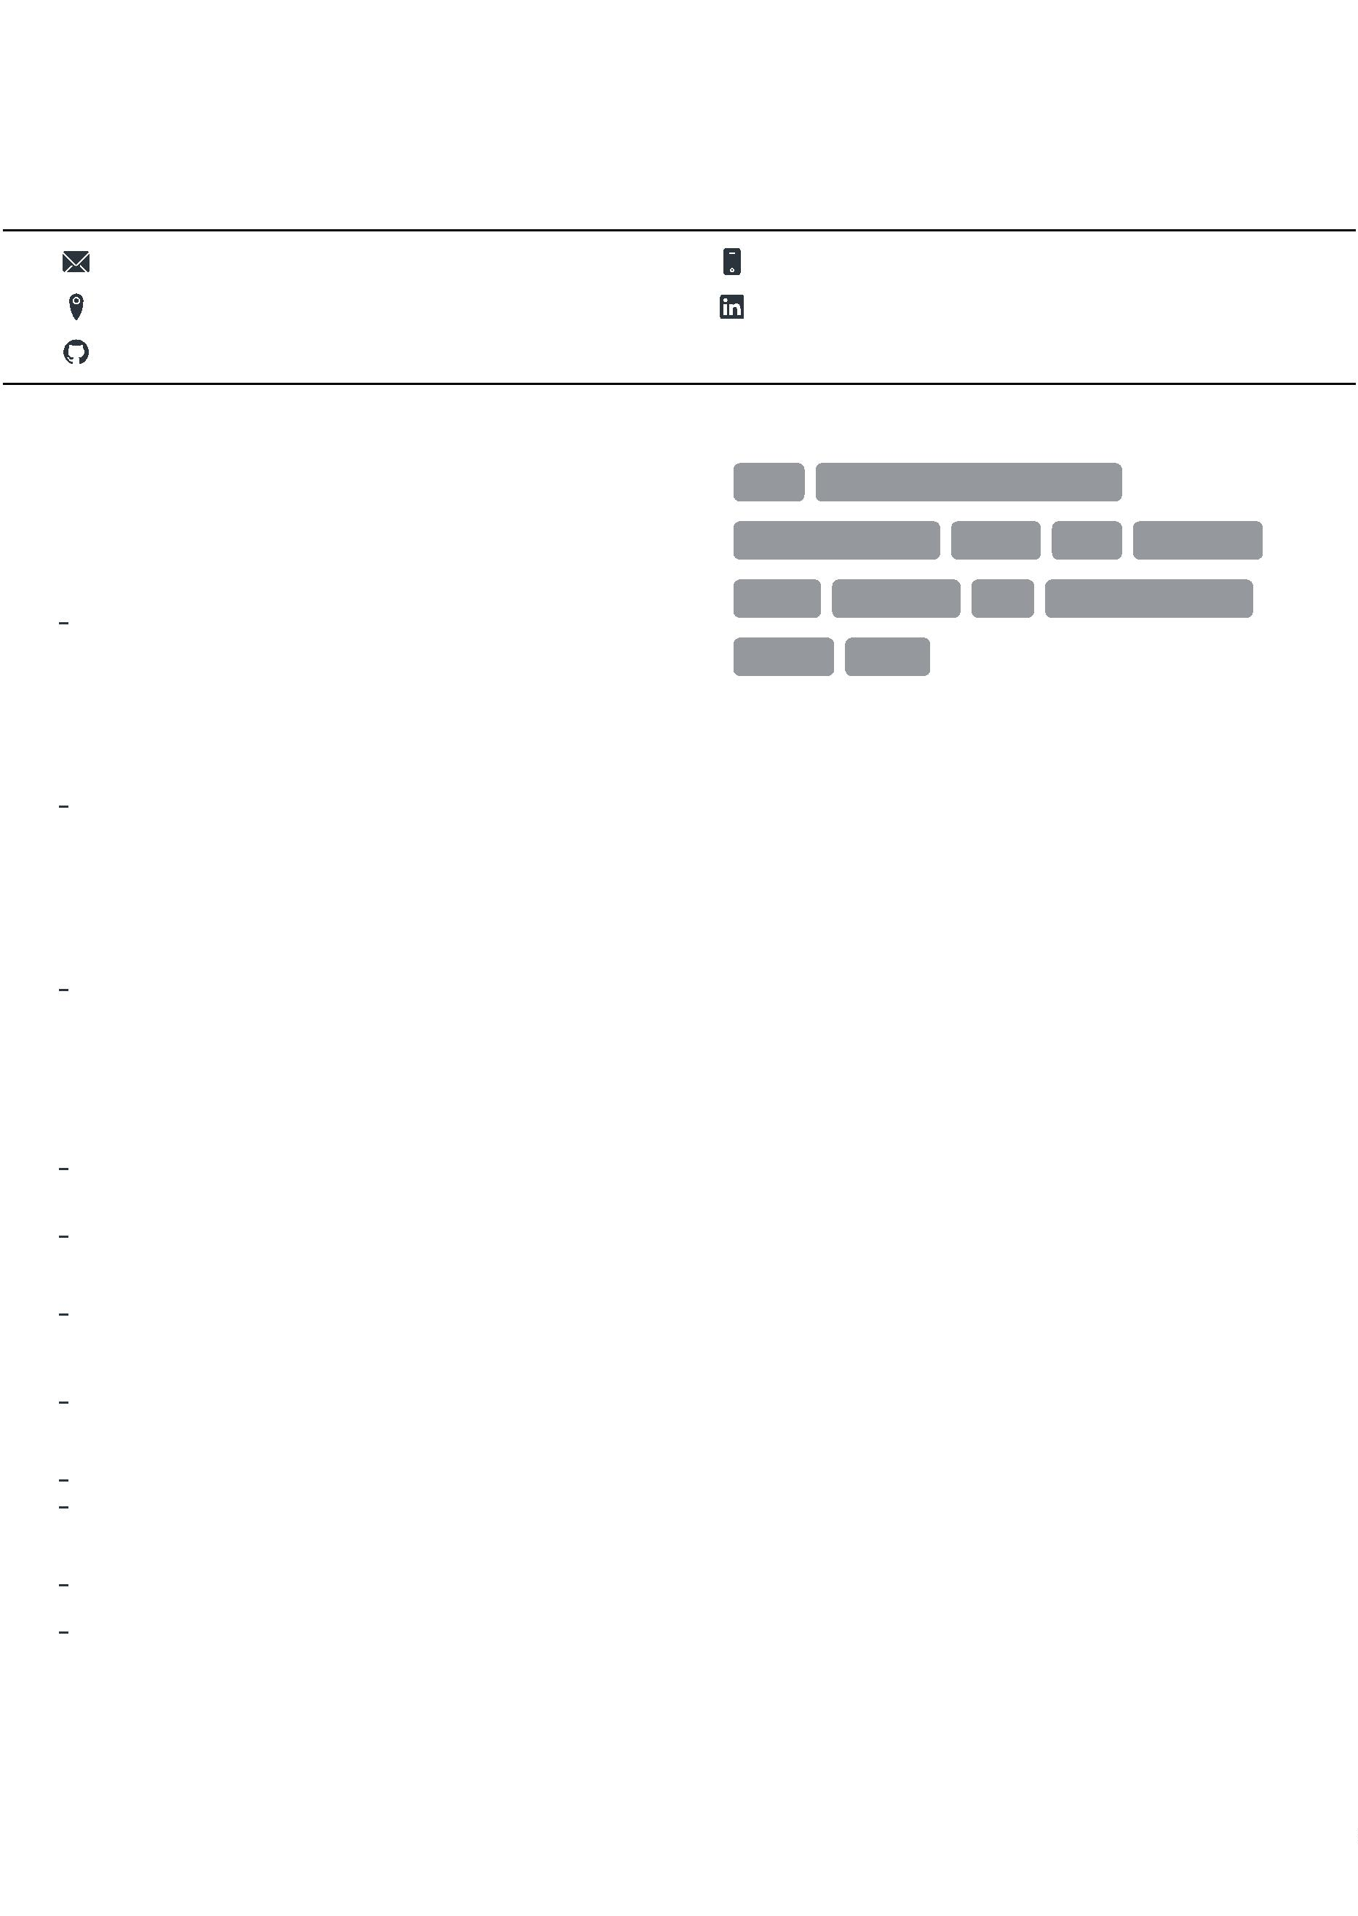
VIKAS TIWARI
Recent Information Technology graduate with a strong foundation in programming languages such as C++,Java, HTML, CSS, and
JavaScript. Eager to apply academic knowledge to real-world software development. A quick learner with a passion for creating
innovative and user-friendly web applications.
vikas20t@gmail.com
New Delhi
9873245628
linkedin.com/in/vikas-tiwari-8ab737228
github.com/VikasTiwari5628
EDUCATION
SKILLS
Bachelor of Technology
C++
Data Structure and Algorithm
Noida Institute of Engineering and Technology,
Greater Noida
Web Development
HTML
Git
CSS
JavaScript
07/2019 - 07/2023,
7.6 CGPA
Courses
React
Bootstrap
Linux
Responsive Design
Information Technology
MySQL
Intermediate
Kendriya Vidyalaya No. 1, New Delhi
04/2017 - 04/2018,
66%
ACHIEVEMENTS
Board
CBSE
200+ Quality DSA Problems solved on GFG, LeetCode,
HackerRank & InterviewBit.
High School
Kendriya Vidyalaya No. 1, New Delhi
Udemy Full-stack Web Development.
04/2015 - 04/2016,
9.6 CGPA
Board
Windows Virtualization Windows ITO + ITIL training.
BEC (Business English Certiﬁcate) Qualiﬁed.
Winner at Inter College Football Championship 2022.
CBSE
PROJECTS
E-commerce Website:
Develop a fully functional e-commerce site with features like product
listings, user authentication, shopping cart, and payment gateway
integration.
LANGUAGES
English
Hindi
Technologies: HTML, CSS, JavaScript, React, jQuery, Bootstrap.
Full Professional Proﬁciency
Full Professional Proﬁciency
Task Manager Application
Created a simple task manager application where users can add, edit,
and delete tasks. The application will have a responsive design and
will use React for the UI components, Bootstrap for styling, and
jQuery for handling certain interactive elements.
Technologies: HTML, CSS, JavaScript, React.
Netﬂix Homepage Clone
Created a responsive Frontend of Netﬂix application.
Technologies: HTML, CSS, JavaScript, React, jQuery, Bootstrap.
Personal portfolio Website
Created a portfolio website. Implemented a responsive design and
showcased various projects, skills, and achievements.
Technologies: HTML, CSS, JavaScript.

